**My Athletics Journey**

Name:…………………………………



Through PE and sport, children will be aware of their own personal strengths and capabilities as well as those of others. Accompanying this, children will also be able to assess and identifying ways to improve, develop and hone their skills further.

|  |  |  |  |  |  |  |  |  |
| --- | --- | --- | --- | --- | --- | --- | --- | --- |
|  | | **60m Sprint** | **80m Sprint** | **400m** | **800m** | **60m Hurdles** | **Javelin** | **Long Jump** |
|  |  |  |  |  |  |  |
| **Years 3/4** | **Years 5/6** | **Years 3/4** | **Years 5/6** | **Years 4,5 & 6** | **All** | **All** |
| **BOYS** | **GOLD** | 10.68s | 12.50s | 1.35min | 3m 06s | 12s | 18m | 3.50m |
| **SILVER** | 11.88s | 13.50s | 1m 45s | 3m 33s | 13.50s | 13m | 3m |
| **BRONZE** | 12.36s | 15s | 2m 05s | 4m 25s | 15.50s | 10m | 2.40m |
| **2** | 14.40s | 17s | 2m 30s | 5m 70s | 19s | 5m | 1.80m |
| **1** | 17.76s | 21s | 3m 20s | 8m | 21s | 1m | 1m |
|  |  |  |  |  |  |  |  |  |
| **GIRLS** | **GOLD** | 11.04s | 12.80s | 1m 40s | 3m 20s | 12.50s | 15m | 3.20m |
| **SILVER** | 11.88s | 13.80s | 1m 55s | 4m | 14s | 12m | 2.80m |
| **BRONZE** | 12.72s | 15.30s | 2m 10s | 4m 40s | 16s | 9m | 2.30m |
| **2** | 14.64s | 17.30s | 2m 30s | 5m 30s | 19.30s | 5m | 1.80m |
| **1** | 17.76s | 21s | 3m 20s | 6m 15s | 22s | 1m | 1m |

|  |  |  |  |  |  |  |  |
| --- | --- | --- | --- | --- | --- | --- | --- |
|  | **60m Sprint** | **80m Sprint** | **400m** | **800m** | **60m Hurdles** | **Javelin** | **Long Jump** |
| **PB 1** |  |  |  |  |  |  |  |
| **PB 2** |  |  |  |  |  |  |  |
| **PB 3** |  |  |  |  |  |  |  |
| **PB 4** |  |  |  |  |  |  |  |
| **PB 5** |  |  |  |  |  |  |  |
| **PB 6** |  |  |  |  |  |  |  |
| **PB 7** |  |  |  |  |  |  |  |
| **PB 8** |  |  |  |  |  |  |  |
| **PB 9** |  |  |  |  |  |  |  |
| **PB 10** |  |  |  |  |  |  |  |
| **PB 11** |  |  |  |  |  |  |  |
| **PB 12** |  |  |  |  |  |  |  |
| **PB 13** |  |  |  |  |  |  |  |
| **PB 14** |  |  |  |  |  |  |  |
| **PB 15** |  |  |  |  |  |  |  |

*\*PB – personal best*

The men’s Long Jump world record is 8.95m

The women’s Javelin world record is 72.28m!

|  |  |  |  |  |  |  |  |
| --- | --- | --- | --- | --- | --- | --- | --- |
|  | **60m Sprint** | **80m Sprint** | **400m** | **800m** | **60m Hurdles** | **Javelin** | **Long Jump** |
| **PB 1** |  |  |  |  |  |  |  |
| **PB 2** |  |  |  |  |  |  |  |
| **PB 3** |  |  |  |  |  |  |  |
| **PB 4** |  |  |  |  |  |  |  |
| **PB 5** |  |  |  |  |  |  |  |
| **PB 6** |  |  |  |  |  |  |  |
| **PB 7** |  |  |  |  |  |  |  |
| **PB 8** |  |  |  |  |  |  |  |
| **PB 9** |  |  |  |  |  |  |  |
| **PB 10** |  |  |  |  |  |  |  |
| **PB 11** |  |  |  |  |  |  |  |
| **PB 12** |  |  |  |  |  |  |  |
| **PB 13** |  |  |  |  |  |  |  |
| **PB 14** |  |  |  |  |  |  |  |
| **PB 15** |  |  |  |  |  |  |  |

The men’s 800m world record is 1 min 40secs!

The women’s 100m world record is 10.49seconds!

|  |  |  |  |  |  |  |  |
| --- | --- | --- | --- | --- | --- | --- | --- |
|  | **60m Sprint** | **80m Sprint** | **400m** | **800m** | **60m Hurdles** | **Javelin** | **Long Jump** |
| **PB 1** |  |  |  |  |  |  |  |
| **PB 2** |  |  |  |  |  |  |  |
| **PB 3** |  |  |  |  |  |  |  |
| **PB 4** |  |  |  |  |  |  |  |
| **PB 5** |  |  |  |  |  |  |  |
| **PB 6** |  |  |  |  |  |  |  |
| **PB 7** |  |  |  |  |  |  |  |
| **PB 8** |  |  |  |  |  |  |  |
| **PB 9** |  |  |  |  |  |  |  |
| **PB 10** |  |  |  |  |  |  |  |
| **PB 11** |  |  |  |  |  |  |  |
| **PB 12** |  |  |  |  |  |  |  |
| **PB 13** |  |  |  |  |  |  |  |
| **PB 14** |  |  |  |  |  |  |  |
| **PB 15** |  |  |  |  |  |  |  |

The men’s world record Javelin throw is 104.80m! WOW!

The women’s 400m world record is 47.60!



|  |  |  |  |  |  |  |
| --- | --- | --- | --- | --- | --- | --- |
|  | **Standing Long Jump** | **Standing Triple Jump** | **Foam Javelin** | **Speed Bounce** | **10x10 Sprint** | **Chest Push** |
| **PB 1** |  |  |  |  |  |  |
| **PB 2** |  |  |  |  |  |  |
| **PB 3** |  |  |  |  |  |  |
| **PB 4** |  |  |  |  |  |  |
| **PB 5** |  |  |  |  |  |  |
| **PB 6** |  |  |  |  |  |  |
| **PB 7** |  |  |  |  |  |  |
| **PB 8** |  |  |  |  |  |  |
| **PB 9** |  |  |  |  |  |  |
| **PB 10** |  |  |  |  |  |  |
| **PB 11** |  |  |  |  |  |  |
| **PB 12** |  |  |  |  |  |  |
| **PB 13** |  |  |  |  |  |  |
| **PB 14** |  |  |  |  |  |  |
| **PB 15** |  |  |  |  |  |  |

The first written records of ancient Olympics date back to 776 BC!

The first modern Olympics was held in Athens, 1896.

|  |  |  |  |  |  |  |
| --- | --- | --- | --- | --- | --- | --- |
|  | **Standing Long Jump** | **Standing Triple Jump** | **Foam Javelin** | **Speed Bounce** | **10x10 Sprint** | **Chest Push** |
| **PB 1** |  |  |  |  |  |  |
| **PB 2** |  |  |  |  |  |  |
| **PB 3** |  |  |  |  |  |  |
| **PB 4** |  |  |  |  |  |  |
| **PB 5** |  |  |  |  |  |  |
| **PB 6** |  |  |  |  |  |  |
| **PB 7** |  |  |  |  |  |  |
| **PB 8** |  |  |  |  |  |  |
| **PB 9** |  |  |  |  |  |  |
| **PB 10** |  |  |  |  |  |  |
| **PB 11** |  |  |  |  |  |  |
| **PB 12** |  |  |  |  |  |  |
| **PB 13** |  |  |  |  |  |  |
| **PB 14** |  |  |  |  |  |  |
| **PB 15** |  |  |  |  |  |  |

USA have won the most medals out of all countries with 2804!

Sports Hall Athletics was formed in 2005!

|  |  |  |  |  |  |  |
| --- | --- | --- | --- | --- | --- | --- |
|  | **Standing Long Jump** | **Standing Triple Jump** | **Foam Javelin** | **Speed Bounce** | **10x10 Sprint** | **Chest Push** |
| **PB 1** |  |  |  |  |  |  |
| **PB 2** |  |  |  |  |  |  |
| **PB 3** |  |  |  |  |  |  |
| **PB 4** |  |  |  |  |  |  |
| **PB 5** |  |  |  |  |  |  |
| **PB 6** |  |  |  |  |  |  |
| **PB 7** |  |  |  |  |  |  |
| **PB 8** |  |  |  |  |  |  |
| **PB 9** |  |  |  |  |  |  |
| **PB 10** |  |  |  |  |  |  |
| **PB 11** |  |  |  |  |  |  |
| **PB 12** |  |  |  |  |  |  |
| **PB 13** |  |  |  |  |  |  |
| **PB 14** |  |  |  |  |  |  |
| **PB 15** |  |  |  |  |  |  |

Usain Bolt is the fastest sprinter ever. He ran the 100m in 9:58secs!

The games were held in the name of Zeus, one of the Greek gods.

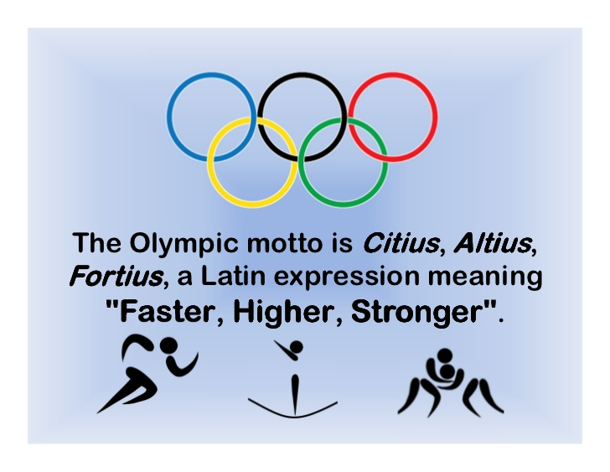



STRIVE TO BE THE BEST THAT YOU CAN BE!