Key Stage 1

Physical Education Lessons at home

KS1 Lesson 1
‘Stamina and Balance’

For each P.E lesson you will focus on two areas. Today you will develop your stamina and your co-ordination.
Stamina – Stamina means you can keep on doing something without stopping
Balance – Can you hold yourself still in different positions

Stamina Activity 1 – The Coconut Shy!
Find a sensible place to play, some soft targets to aim at & grab a ball. Try and place these targets at a variety of heights to test your skills. Maybe you could use teddy bears?

Decide on how many goes each you have and take it in turns to see who can throw the socks and knock over the most targets.

After each attempt to hit a target you must run up and down your playing area 3 times!

To make it harder – use smaller targets or move further away!

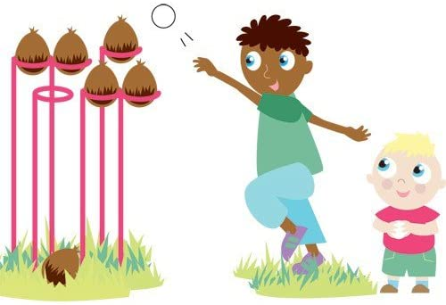

Balance Activity 1 – It’s yoga time!

Have a go at this Cosmic Kids Yoga work out and try your best to complete the whole thing perfectly!

https://www.youtube.com/watch?v=xlg052EKMtk&t=852s

Good luck and enjoy!

Stamina Activity 2 – Heart Rate Challenge!

How long can you go? The challenge is simple yet challenging. You’ll need a stopwatch or something/someone to time you.
Once ready start jogging, the challenge is then to see how long you can run for before you have to walk/stop. Pace yourself – this means don’t run too fast, too soon. Have a small rest once you have completed your first attempt – then try and beat it by another ten seconds or more!

KS1 Lesson 2

Stamina Activity 1 - 90 second Shuttle Challenge

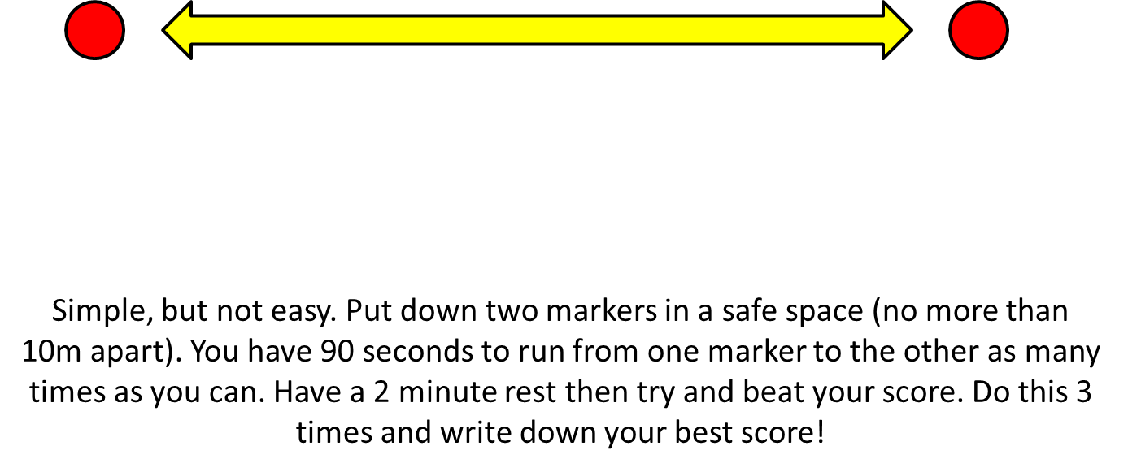

Balance Activity 1 – Gymnastics training!

Follow the link below and have fun training like a gymnast!

https://www.youtube.com/watch?v=JfAqMb6BGH8

Well done and enjoy!

Stamina Activity 2 – Empty vs Fill

‘Empty vs Fill’
You’ll need to find someone to play against!
One player takes the role of ‘empty’ and the other ‘fill’. You’ll need something empty – a box or a bucket. Roll up about 8/9 sock balls.
Around your bucket try and mark out the perimeter of the pitch.
Set a timer (start with a 30 second game)
Put all of the sock balls in the bucket. ‘Empty’ tries to empty the bucket (they can’t throw the sock balls pass the perimeter of the pitch) whilst ‘Fill’ tries to put them back in!
This is both silly and simple, but it will help your child develop spatial awareness and begin to consider where to aim shots to ensure success.
Oh and no knees allowed on the floor!

KS1 Lesson 3
‘Stamina and Balance’

Stamina Activity 1 – Rock, Paper, Scissors – Workout!
Time to get hot and out of breath!
The first game is really simple but really fun (I hope). You will need at least one person to play against.
First you will have to play Rock, Paper, Scissors against your opponent.
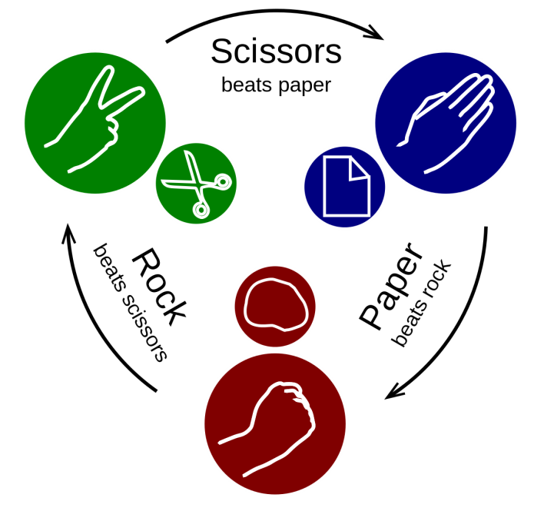
Whoever wins gets to pick a physical forfeit for the loser!
So if you can manage to win your game you can make the other play do any exercise you wish 10 times (10 Jumping Jacks, 10 Shoulder touch press ups, 10 Space Rockets etc)
If you manage to win 3 games in a row you double your opponents forfeit! So they’ll have to do 20!

Balance activity 1 – Gymnastics routine!

Practice each of the balances on these pictures for 5 seconds. They get harder the higher you get!
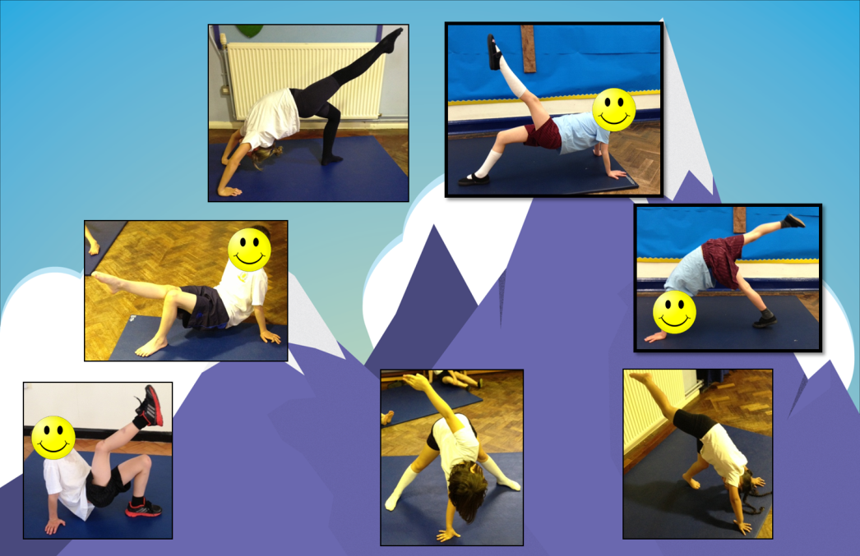
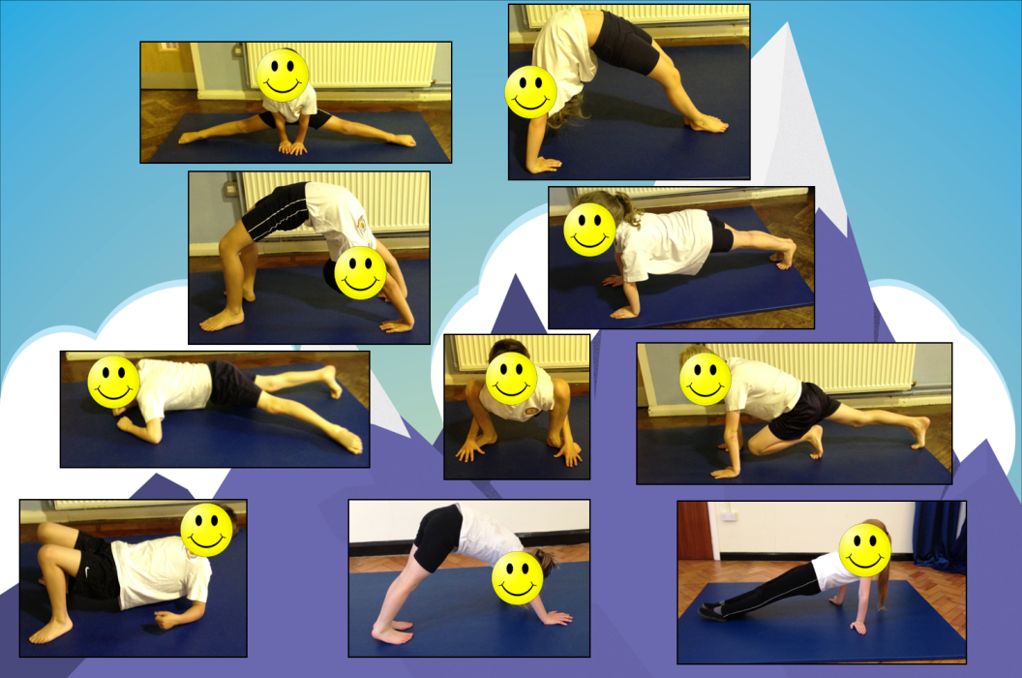

Once you have practiced all of them three or four times it is time to make a routine!
To make a routine you need to link 3 or 4 of these balances together without standing up. Remember to do your start and finish position to let the judges know when you’re starting your routine.

Stamina Activity 2 – Bank Robbers: Against the clock!

For this game you will pretend you’re robbing a bank (You’ll need some sort of stopwatch). Roll up lots of socks and other gather up lots of toys that don’t break very easy – in the game we will pretend that these items are bags of golden coins!

Place them all at one end of your garden/playing area.

For this game you will have 2 minutes.

When the timer starts you have to run as fast as you can across your playing area and pick up one ‘golden coin’ – then run and place it in your swag bag. Keep running and fetching golden coins until your time runs – then count how ‘coins’ you’ve collected and how devious you have been! MWAHAHAHAAAAA (That’s a villain laugh by the way).

You have 4 attempts at this game. Write down your highest score and send it to your teacher!
P.E – You’re supposed to red hot and sweaty when this finishes. So if you’re not….DO IT AGAIN!

KS1 Lesson 4

‘Stamina and Balance’

Stamina Activity 1 – Sumo Tail Tag!

This game is one of my favourites. The first thing you will need is someone to play against (if everyone at home is busy, then just save the game for another point later today).

Mark out a circle pitch in your playing area.
Each player must tuck a bib/t-shirt/tea towel to make a tail. The tail needs to be tucked into the side of your shorts/trousers.
Without leaving the circle, one player has to attempt to pull out their opponents bib to win! (You will be attempting to do this to each other at the same time)
You are not allowed to touch your opponent – you can only touch their ‘tail’.

To add some extra spice to the game you could play ‘best of 3’. The loser has to do a physical forfeit that the winner chooses!

Enjoy!

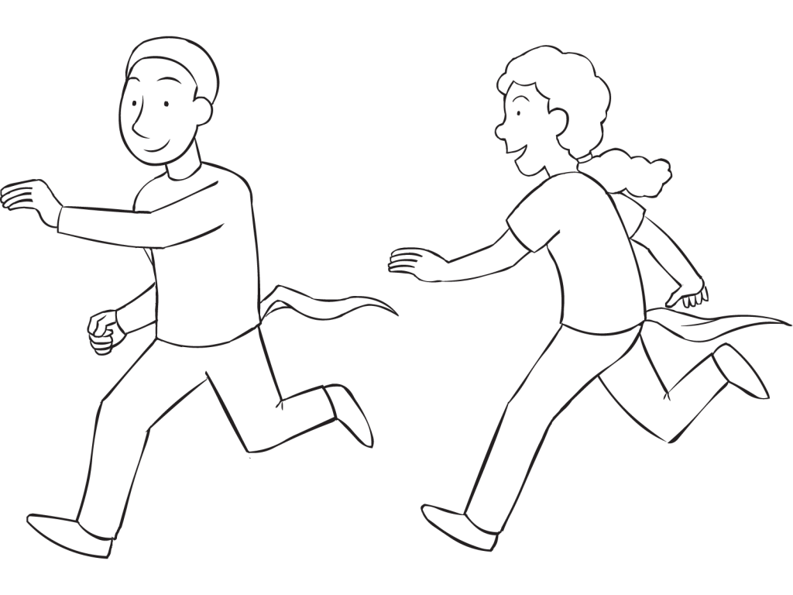

Balance activity 1 – Gymnastics routine Part 2!

In your last lesson you created a gymnastics routine using the balances below:

Your first task is to practice all of the balances three times (hold each balance for 5 seconds each). Concentrate on two areas today:

- Control – How still you can be whilst holding the balance
- Extension –Can you hold your legs and arms straight with pointy fingers and toes
Once you have practiced all of the balances, concentrating on your control and extension, it is time to develop your routine!
In this lesson you are going to add a travel to your routine. ‘Travelling’ in Gymnastics mean you move from one place to the another – but we don’t want you to just walk. Instead try some of these…

Try and add a different way to travel in between in each of the balances in your routine. Good luck and enjoy!
Stamina Activity 2 – Kids workout time!

As we know our body changes when we do more exercise – the more we do, the stronger it gets.

Follow the link below and complete the kids workout with Mr. Joe Wicks.

https://www.youtube.com/watch?v=mhHY8mOQ5eo&t=458s

I wonder if you convince someone else to join in with you for a bonus point?

KS1 Lesson 5

‘Stamina and Co-ordination’

Stamina Activity 1 – Bank Robbers: Against the clock!

For this game you will pretend you’re robbing a bank (You’ll need some sort of stopwatch). Roll up lots of socks and other gather up lots of toys that don’t break very easy – in the game we will pretend that these items are bags of golden coins!

Place them all at one end of your garden/playing area.

For this game you will have 2 minutes.

When the timer starts you have to run as fast as you can across your playing area and pick up one ‘golden coin’ – then run and place it in your swag bag. Keep running and fetching golden coins until your time runs – then count how ‘coins’ you’ve collected and how devious you have been! MWAHAHAHAAAAA (That’s a villain laugh by the way).

You have 4 attempts at this game. Write down your highest score and send it to your teacher!
P.E – You’re supposed to red hot and sweaty when this finishes. So if you’re not….DO IT AGAIN!

Co-ordination Activity 1 – The Golden Ladder
This is a fun game to help improve the accuracy of your throwing. At home we lie out t shirts as targets (unless you have 5 buckets/hoops) and use rolled up socks to throw. Enjoy!
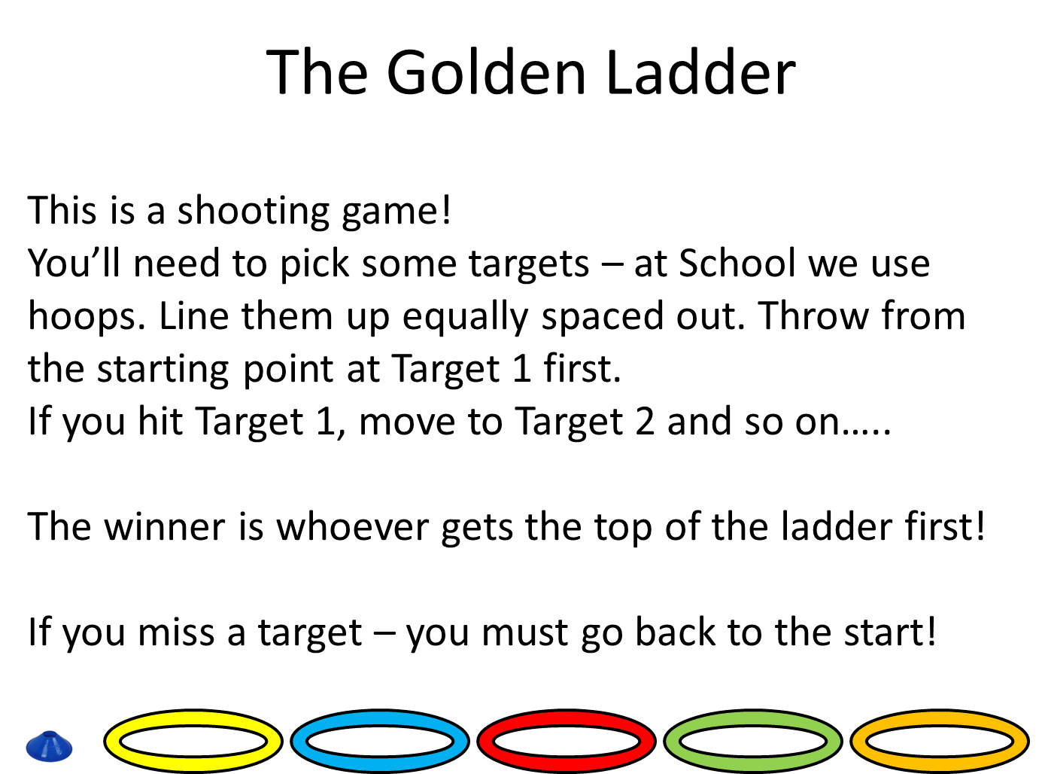

Stamina Activity 2 – Clean vs Messy!
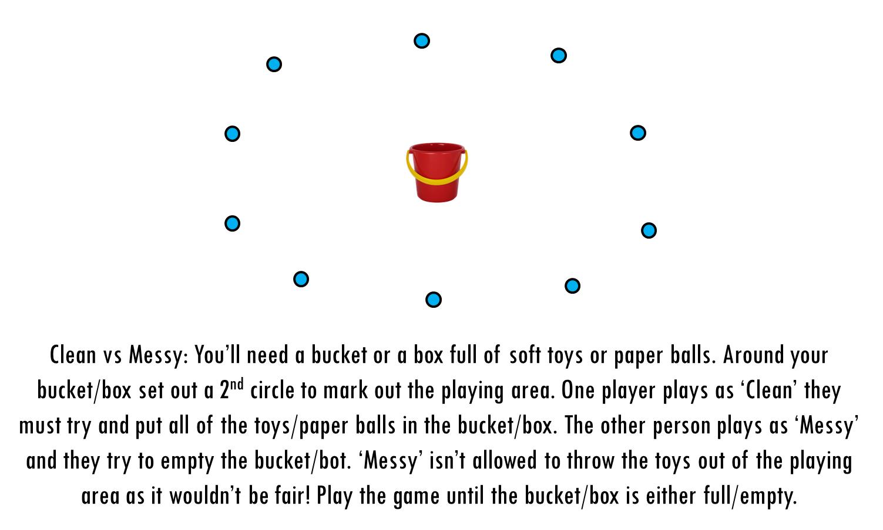

KS1 Lesson 6

‘Stamina and Co-ordination’

Stamina – Activity 1

How long can you go? The challenge is simple yet challenging. You’ll need a stopwatch or something/someone to time you.
Once ready start jogging, the challenge is then to see how long you can run for before you have to walk/stop. Pace yourself – this means don’t run too fast, too soon. Have a small rest once you have completed your first attempt – then try and beat it by another ten seconds or more!

Co-ordination – Activity 1
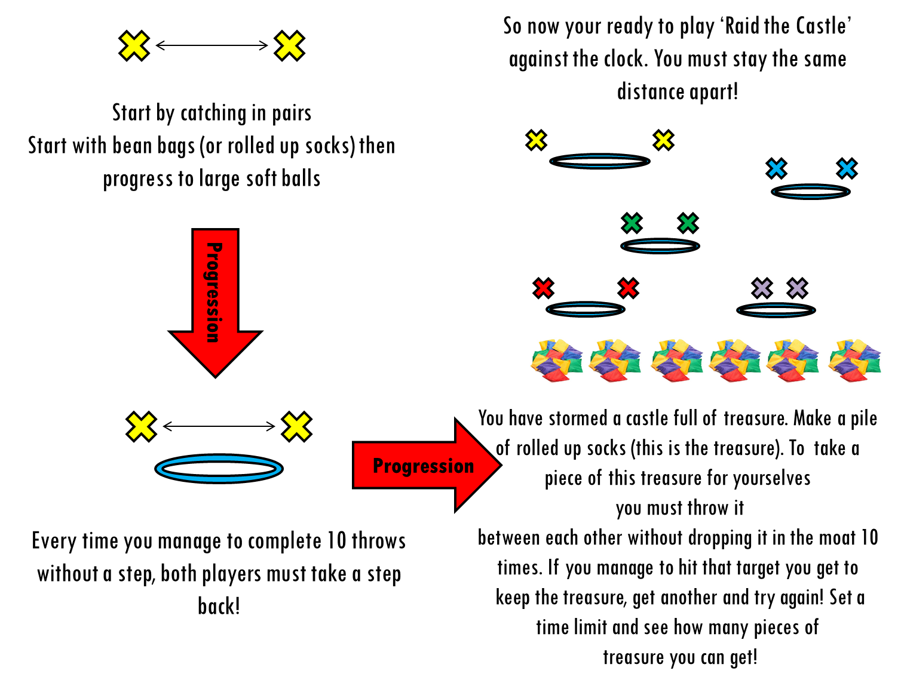
Stamina – Activity 2

You’re going to repeat a game from a previous lesson now. Your job is to try and beat the score that you got the last time we played it. You can do this!

Stamina Activity 1 - 90 second Shuttle Challenge

