Key Stage 1

Physical Education Lessons at home

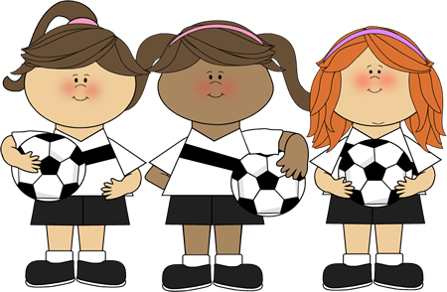

KS1 Lesson 1
‘Stamina and Balance’

For each P.E lesson you will focus on two areas. Today you will develop your stamina and your co-ordination.
Stamina – Stamina means you can keep on doing something without stopping
Balance – Can you hold yourself still in different positions

Stamina Activity 1 – The Coconut Shy!
Find a sensible place to play, some soft targets to aim at & grab a ball. Try and place these targets at a variety of heights to test your skills. Maybe you could use teddy bears?

Decide on how many goes each you have and take it in turns to see who can throw the socks and knock over the most targets.

After each attempt to hit a target you must run up and down your playing area 3 times!

To make it harder – use smaller targets or move further away!

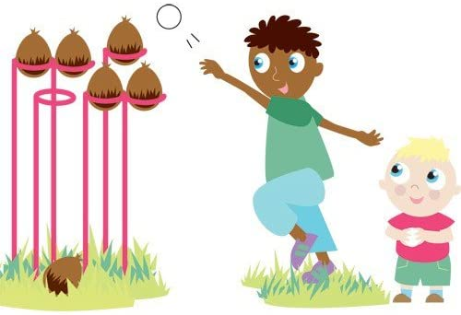

Balance Activity 1 – It’s yoga time!

Have a go at this Cosmic Kids Yoga work out and try your best to complete the whole thing perfectly!

https://www.youtube.com/watch?v=xlg052EKMtk&t=852s

Good luck and enjoy!

Stamina Activity 2 – Heart Rate Challenge!

How long can you go? The challenge is simple yet challenging. You’ll need a stopwatch or something/someone to time you.
Once ready start jogging, the challenge is then to see how long you can run for before you have to walk/stop. Pace yourself – this means don’t run too fast, too soon. Have a small rest once you have completed your first attempt – then try and beat it by another ten seconds or more!

KS1 Lesson 2

Stamina Activity 1 - 90 second Shuttle Challenge

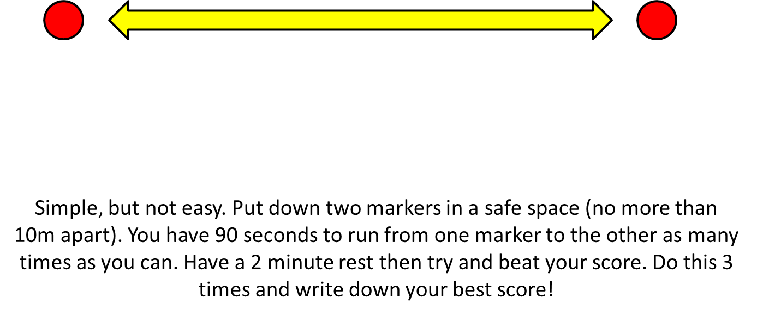

Balance Activity 1 – Gymnastics training!

Follow the link below and have fun training like a gymnast!

https://www.youtube.com/watch?v=JfAqMb6BGH8

Well done and enjoy!

Stamina Activity 2 – Empty vs Fill

‘Empty vs Fill’
You’ll need to find someone to play against!
One player takes the role of ‘empty’ and the other ‘fill’. You’ll need something empty – a box or a bucket. Roll up about 8/9 sock balls.
Around your bucket try and mark out the perimeter of the pitch.
Set a timer (start with a 30 second game)
Put all of the sock balls in the bucket. ‘Empty’ tries to empty the bucket (they can’t throw the sock balls pass the perimeter of the pitch) whilst ‘Fill’ tries to put them back in!
This is both silly and simple, but it will help your child develop spatial awareness and begin to consider where to aim shots to ensure success.
Oh and no knees allowed on the floor!

