Lower Key Stage 2

Physical Education Lessons at home

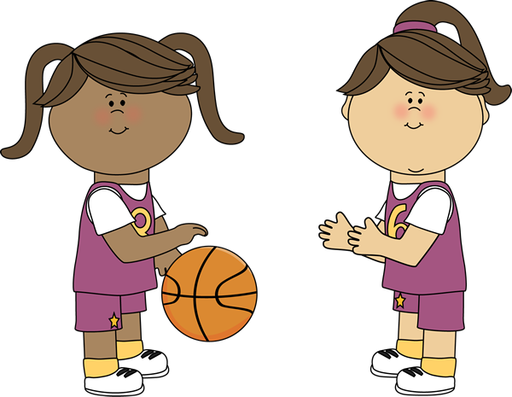

LKS2 Lesson 1
‘Stamina and Co-ordination’

For each P.E lesson you will focus on two areas. Today you will develop your stamina and your co-ordination.
Stamina – Stamina means you can keep on doing something without stopping
Co-ordination – In today’s lesson you’ll develop your ability to throw to a target.

Stamina Activity 1 - 90 second Shuttle Challenge

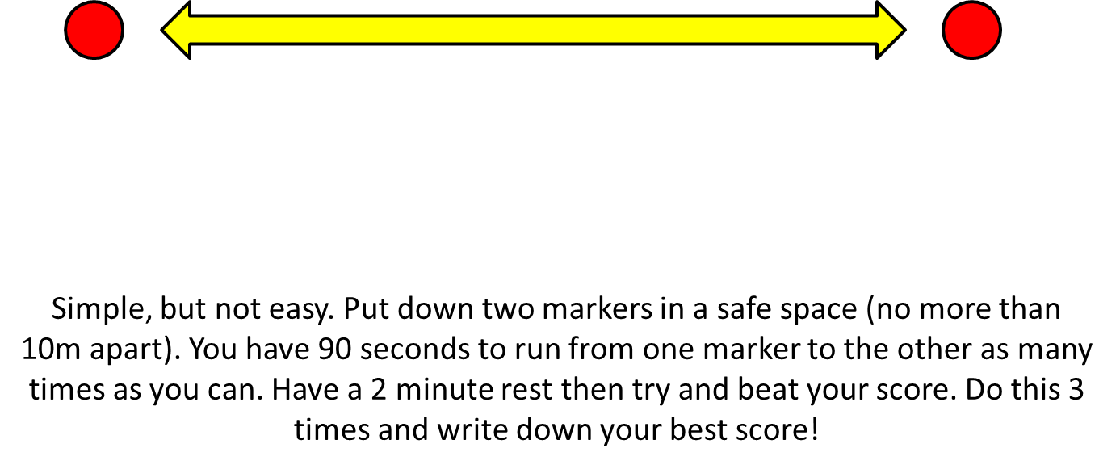

Co-ordination Activity 1 – The Golden Ladder
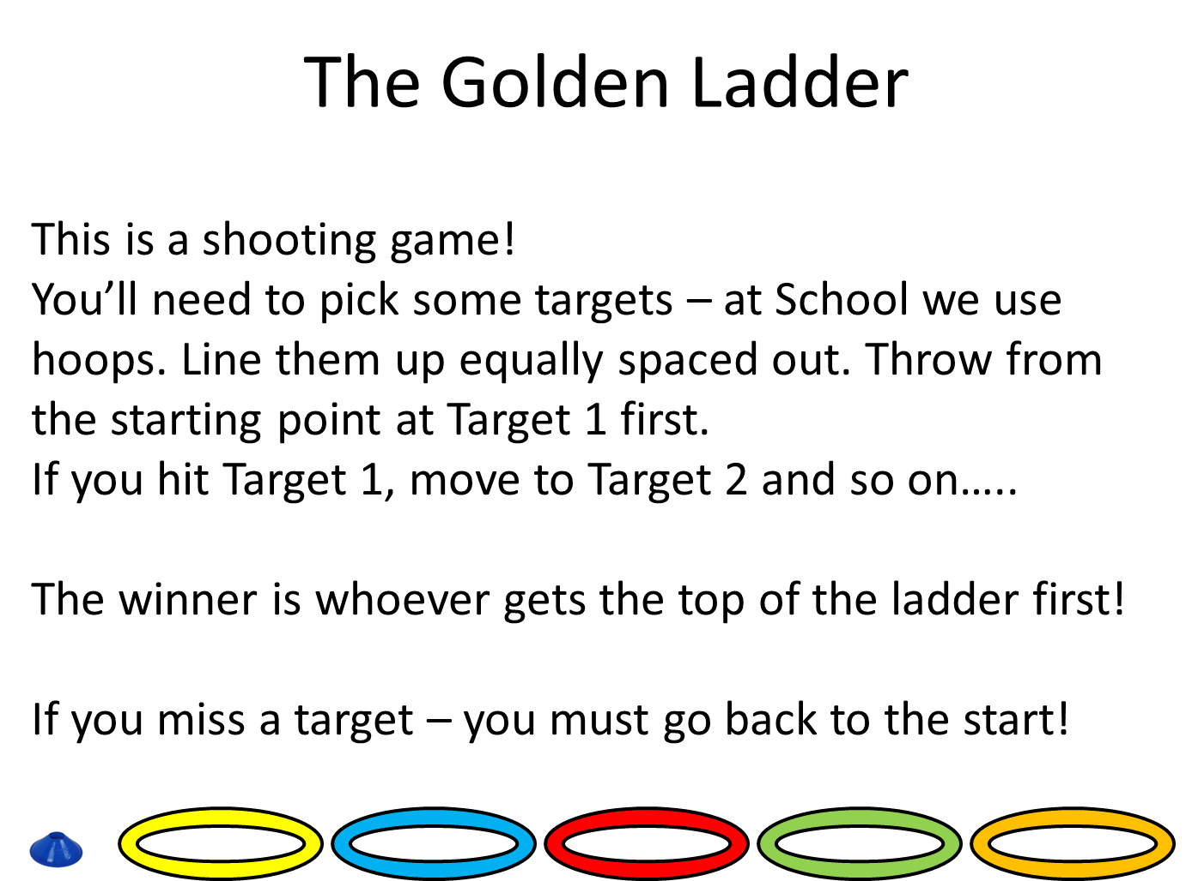

Stamina – Activity 2
*See if you can persuade people with you to join in, the more the merrier!*
It’s time for a workout. See if you can keep up for the whole video!
P.S – Your muscles will change over time depending on how much you move your body!
Follow the link below:
https://www.youtube.com/watch?v=5if4cjO5nxo&t=595s

LKS2 Lesson 2
‘Stamina and Co-ordination’

Stamina – Stamina means you can keep on doing something without stopping
Co-ordination – In today’s lesson you’ll develop your ability to throw to a target.

Stamina – Activity 1

How long can you go? The challenge is simple yet challenging. You’ll need a stopwatch or something/someone to time you.
Once ready start jogging, the challenge is then to see how long you can run for before you have to walk/stop. Pace yourself – this means don’t run too fast, too soon. Have a small rest once you have completed your first attempt – then try and beat it by another ten seconds or more!

Co-ordination – Activity 1
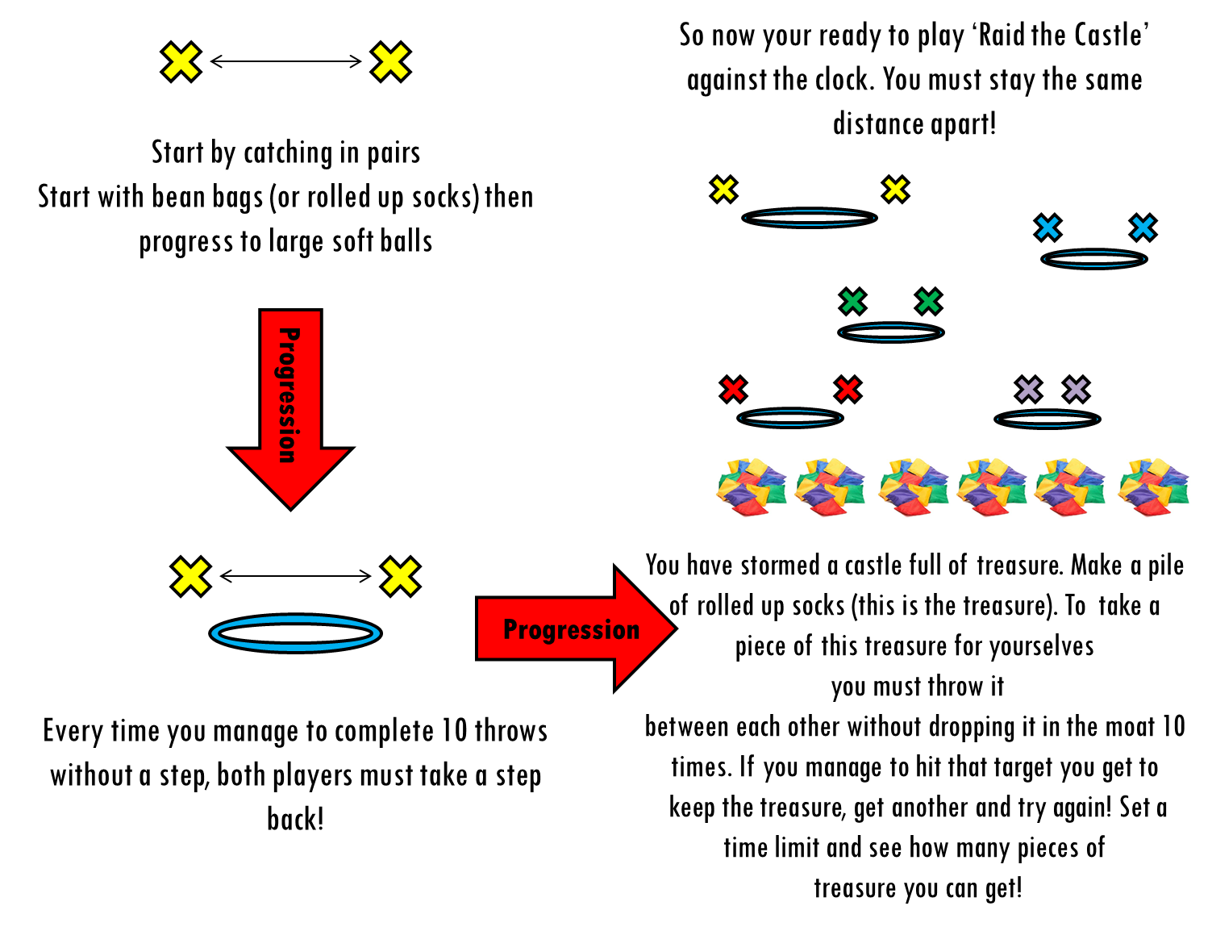
Stamina – Activity 2
‘Empty vs Fill’
You’ll need to find someone to play against!
One player takes the role of ‘empty’ and the other ‘fill’. You’ll need something empty – a box or a bucket. Roll up about 8/9 sock balls.
Around your bucket try and mark out the perimeter of the pitch.
Set a timer (start with a 30 second game)
Put all of the sock balls in the bucket. ‘Empty’ tries to empty the bucket (they can’t throw the sock balls pass the perimeter of the pitch) whilst ‘Fill’ tries to put them back in!
This is both silly and simple, but it will help your child develop spatial awareness and begin to consider where to aim shots to ensure success.
Oh and no knees allowed on the floor!

