Upper Key Stage 2

Physical Education Lessons at home

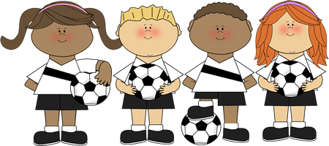

UKS2 Lesson 1
‘The Science Experiment’
For lesson 1 you have to complete a series of challenges and we would like you to pay attention to how your body changes. One easy way to do this is by checking your pulse (this is a measurement of how fast your heart is beating).
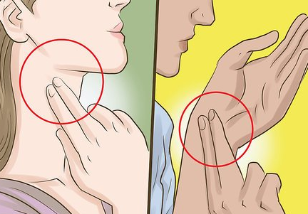
As you complete each challenge in our Science experiment write out your heart rate in the table below. Your heart rate is how many times you feel your heart beat in 60 seconds, so after completing the exercise find your pulse (see the picture) and count for 60 seconds!
The Science Experiment!
Challenge Number | The Challenge | Heart Rate (Count your pulse for 60 seconds)
1 | Lie completely still for 2 minutes
2 | Cross your arms and legs and sit for 1 minute
3 | Walk for 1 minute
4 | Jumping Jacks for 1 minute
5 | Jog on the spot for 1 minute
6 | Shoulder touch press ups for 1 minute
7 | Burpees for 1 minute!

You may have noticed that as the challenges get harder, your heart rate gets higher!
This is because your muscles use oxygen as fuel. So the harder you work the more oxygen you need, which means you breathe faster and your heart pumps the blood which carries the oxygen faster.
With that in mind – here is your next challenge. Complete this workout and every 3 minutes pause the video and find your pulse and count your heart rate.
Click the link and get ready!
https://www.youtube.com/watch?v=4dPXtS1aUII

Well done everyone!

UKS2 Lesson 2
‘Types of Training’
In this lesson we are going to learn about different ways to train your body. For every type of training we would like you to think about 2 things. 1) How hard did you find it? 2) Did you find it fun?
For each activity can you give it a score out of 16 for how hard you found it. 16 means it is as hard as running a marathon, 1 means you found it as easy as lying down with your favourite book!
Training 1: The first type of training you will do is called ‘Continuous Training’. This means you do the same type as exercise for a period of time without stopping. For this training you to do both of these activities please.
Continuous Training 1 – 3 minutes of continuous jogging without stopping
Continuous Training 2 – 90 seconds of continuous Jumping Jacks
Positives | - You don’t need much equipment to do it  - It works! If you do continuous training for long enough you will get fitter!  - Some people enjoy the feeling of going for a long run, bike ride to relax
Negatives | - It isn’t very sociable (you would normally do this type of exercise alone)  - Some people can find doing the same thing for a long time boring

Training 2:
Interval Training – The word interval means break. So for interval training you do exercise then you get a small chance to get your breath back before you start again. It means you can work a bit harder when it is your time to exercise again.
*Try and get someone else to join in with you*
Follow the link below and don’t forget to give the activity a score out of 16. Enjoy!
https://www.youtube.com/watch?v=591Stmzm9EA
Positives | - You get frequent rests, which means you can work harder!  - You can change how long you rest for – the fitter you get, the harder it gets!  - It works! You will get fitter!
Negatives | - It takes a bit of planning if you wanted to do it alone  - Or you’ll need to get some equipment if you want copy from a video (tablet, laptop etc)

Training 3:
Fartlek Training – Don’t panic, it’s Swedish. In Swedish Fartlek means ‘speed play’. For this type of exercise we’d like you to get used to changing speeds whilst you are running. You might need a bit of extra space for this one – maybe the garden or a park if you have someone to go with?
This is what we want you to try.
Imagine you’re a car with 3 gears (make the engine noise if it helps).
Gear 1 = Walking, Gear 2 = Jogging, Gear 3 = Sprinting
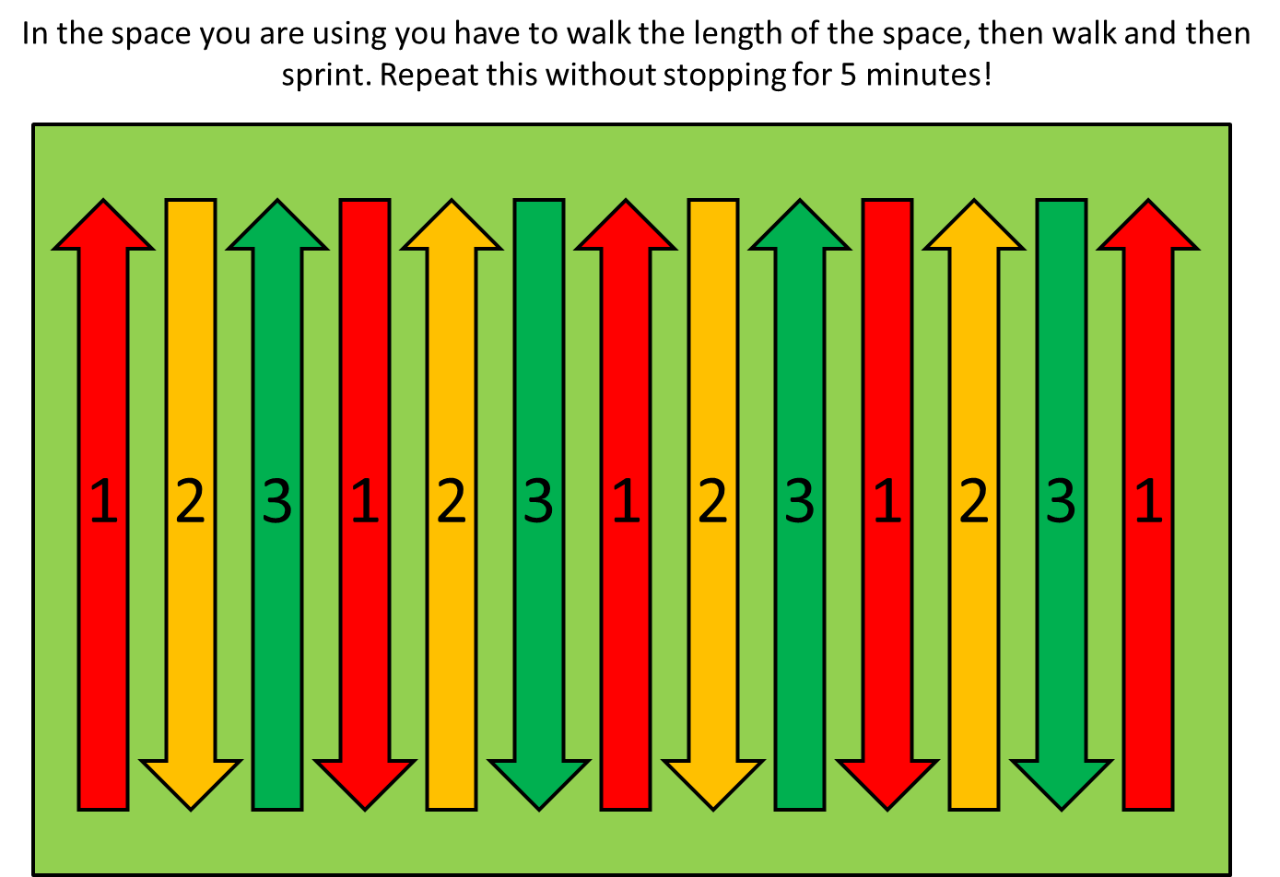
Positives | - It works! You will get fitter  - It is very useful for people who play team games (Hockey, Football, Rugby, Netball etc). The change of speed is the same as how you move when you play these games
Negatives | - Not much fun if you don’t like running!

UKS2 Lesson 3
‘Types of Training Part 2’
Hopefully you will remember that in the last lesson we tried some different types of training and you gave each type a score out of 16 for how hard you found it.
The Borg Scale – The Borg Scale is something we can use to give a numerical score to how hard we find a certain type of exercise. The Borg Scale actually starts at 6, which is the lightest an exercise can be. The highest score on the Borg Scale is 20 – think running a marathon!
Please give all activities in this lesson a Borg Scale rating 6-20 – Thanks!
Some of the types of training we will repeat – but I’d also like you to consider which types of athletes could use these types of training…

Training 1 – Continuous Training
The first type of training you will do is called ‘Continuous Training’. This means you do the same type as exercise for a period of time without stopping. For this training you to do both of these activities please.
Continuous Training 1 – 4 minutes of continuous jogging without stopping
Continuous Training 2 – 90 seconds of continuous Jumping Jacks
Give each type of training a score on the Borg Scale (6-20)

Positives | - You don’t need much equipment to do it  - It works! If you do continuous training for long enough you will get fitter!  - Some people enjoy the feeling of going for a long run, bike ride to relax
Negatives | - It isn’t very sociable (you would normally do this type of exercise alone)  - Some people can find doing the same thing for a long time boring  - Because you never stop, you have to keep steady – so this type of training doesn’t really develop speed or power

What type of athlete would find this training useful?
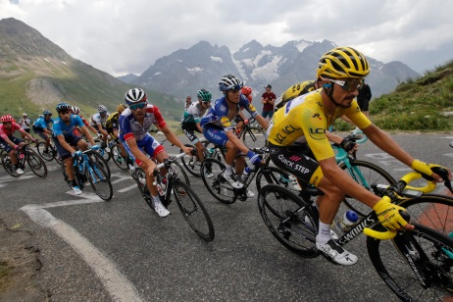

Training 2 – Fartlek Training
In Swedish Fartlek means ‘speed play’. For this type of exercise we’d like you to get used to changing speeds whilst you are running. You might need a bit of extra space for this one – maybe the garden or a park if you have someone to go with?
This is what we want you to try.
Imagine you’re a car with 3 gears (make the engine noise if it helps).
Gear 1 = Walking, Gear 2 = Jogging, Gear 3 = Sprinting
Fartlek Training was created by a professor in Sweden who wanted to train his body to get used to changing speed, similar to how his body moved when he was playing Handball or Hockey.
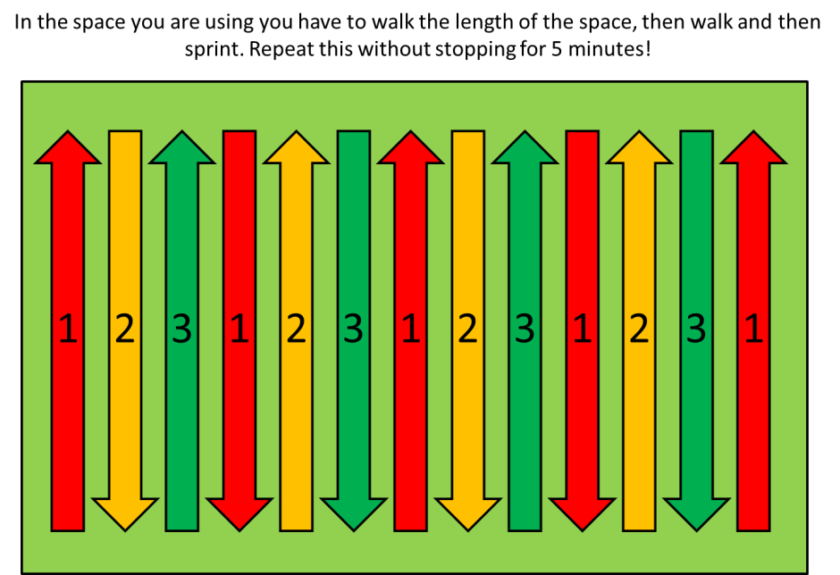
Positives | - It works! You will get fitter  - It is very useful for people who play team games (Hockey, Football, Rugby, Netball etc). The change of speed is the same as how you move when you play these games
Negatives | - Not much fun if you don’t like running!
Give each type of training a score on the Borg Scale (6-20)
What type of athlete would find this training useful?
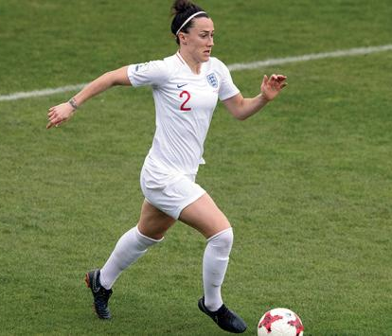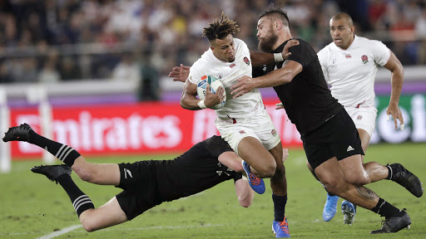
Training 3 – Plyometric Training
Plyometric training is designed to make your muscles work to their maximum. It involves repeating the same movements over and over again – each one making your muscles have to work hard. Plyometric training will help you to become stronger or faster.
So let’s give it a try (There is no way of doing plyometric training and looking cool by the way)
Follow the link below please:
https://www.youtube.com/watch?v=nlsYjZpoQDQ
Positives | - It works! You will get stronger/faster  - You don’t need lots of equipment once you know how to do plyometric training
Negatives | - If you do too much you can overwork your muscles

Give each type of training a score on the Borg Scale (6-20)
What type of athlete would find this training useful?

Training 4 – Flexibility training
Flexibility means how much your body can stretch and bend in certain places. The more you train your body in this way, the greater your range of movement will become.
Click on the link below and give it a try – don’t forget your Borg scale rating please!
https://www.youtube.com/watch?v=L_xrDAtykMI
Positives | - It works! You will become more flexible  - It is essential for all athletes to be as flexible as possible
Negatives | - Not many athletes stretch as much as they should!

UKS2 Lesson 4
Different types of fitness
Task 1 – The first thing I would like you to do is to try and answer this question:
‘Who is the fittest person in the world AND why do you choose them?’
It might be fun to see what the other people you are with think too
If we asked ten people that same question I’m pretty sure lots of people would have different ideas. That is because there are many different types of fitness – in P.E we call these the components of fitness.
The components of fitness are – Agility, Balance, Cardio-Vascular Endurance, Co-ordination, Flexibility, Muscular Endurance, Power, Reaction Time, Strength and Speed.
Some people will be brilliant at some of those components and then find others more difficult.
In this lesson we’re going to learn about some of these components of fitness and I’d like you to consider which of these you find easier and which feel a bit tricky.
Fitness Component 1 – Co-ordination
Co-ordination is how well your eyes, brain and muscles work together. For example can you hit a moving ball with a tennis racquet or catch a fast moving ball whilst running?

We have a simple but fun game to test your co-ordination.
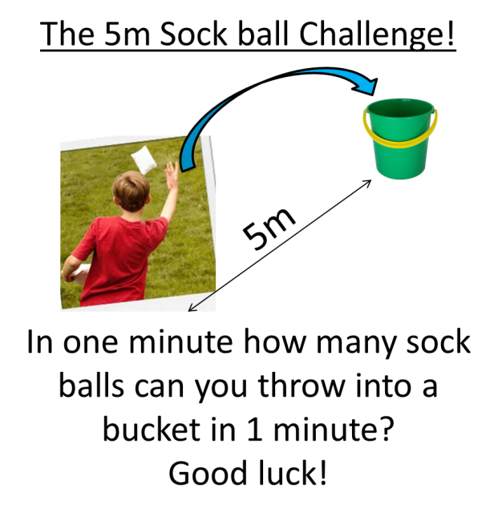
Play this game as many times as you wish. Co-ordination is something you can improve with effective practice.

Fitness Component 2 – Cardio-vascular endurance
Cardio-vascular endurance is basically how well your hearts and lungs work together. Can you get oxygen to your brain and muscles quickly when you are exercising to let you carry on?
To test this we’ll do the 5 minute challenge. Set a timer for 5 minutes and start running. The challenge is to make 5 minutes of running without ever stopping, if you do stop – have a quick breather then get running again!
How easy you find it will be a reflection of your cardio-vascular endurance!

Fitness Component 3 – Muscular Endurance
Muscular Endurance is how easy your muscles to find it to keep on doing a task for a long time. I hope you’ve had your Weetabix!
This is a Shoulder touch press up.
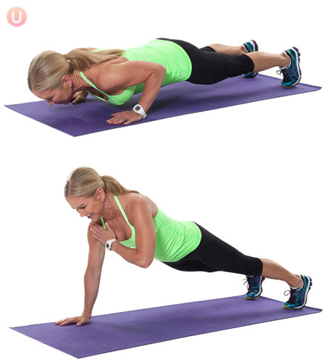
When you touched both shoulders it counts as 1. Your challenge is to see how many you can do in 2 minutes – good luck. Your arms will feel much heavier towards the end of that time!
Fitness Component 4 – Speed
Speed is the fastest a person can move their body.
You’ll need a stopwatch.
Mark out an area as large as possible. It might be an idea to try this is a nearby park or field if you can get someone to go with you.
Once set up you have to sprint as fast as you can from point A to point B. Have 5 or 6 attempts and make a note of your fastest time. Pay attention to if it feels easy moving your body at maximum speed.

UKS2 Lesson 5
Different types of fitness (cont’d)

In this lesson we’ll revisit the components of fitness again. Remember – being physically fit doesn’t just mean you can run for a long time!
The components of fitness are: Agility, Balance, Cardio-Vascular Endurance, Co-ordination, Flexibility, Muscular Endurance, Power, Reaction Time, Strength and Speed.
We’ll repeat some of the activities and try out a few new components of fitness too!
We’ll start with Co-ordination…
Fitness Component 1 – Co-ordination
Co-ordination is how well your eyes, brain and muscles work together. For example can you hit a moving ball with a tennis racquet or catch a fast moving ball whilst running?
We have a simple but fun game to test your co-ordination.
Play this game as many times as you wish. Co-ordination is something you can improve with effective practice.

Fitness Component 2 – Cardio-vascular endurance
Cardio-vascular endurance is basically how well your hearts and lungs work together. Can you get oxygen to your brain and muscles quickly when you are exercising to let you carry on?
To test this we’ll do the 5 minute challenge. Set a timer for 5 minutes and start running. The challenge is to make 5 minutes of running without ever stopping, if you do stop – have a quick breather then get running again!
How easy you find it will be a reflection of your cardio-vascular endurance!

Fitness Component 3 – Flexibility
Flexibility is basically how much movement you have around each joint (knee, hip etc). Like all components of fitness it can be improved if trained correctly. Let’s see how easily it comes to you!
Follow the link below and test your flexibility (this is the one that Mr. Sigley struggles with the most!)
https://www.youtube.com/watch?v=jeNwE4VXqgs
It is important to stretch your muscles and to increase your flexibility – especially if you are very active.

Fitness Component 4 – Agility
Agility is the ability to move quickly and change direction whilst keeping your balance.
To test your agility you can do the Illinois agility run!
Don’t worry if you don’t have enough space to try this exactly the same. We just want you to get the feel of running fast and changing direction – use whatever you can that is safe and try and copy the picture below. Once you have had a few practices, turn up the heat and sprint it as fast as you can!
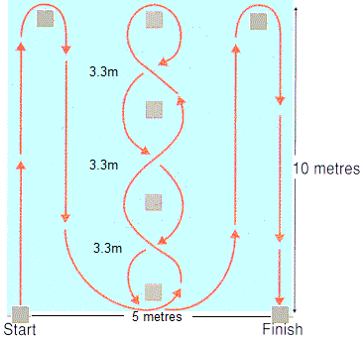

UKS2 Lesson 6
‘Movement and fun!’

There is one other VERY important reason to exercise – to have fun!
All of the activities you will do in this lesson are designed specifically for that purpose. Hopefully to put a smile on your face and get you up and moving – soon we’ll be playing these games all together.

Activity 1 – The Coconut Shy!
Find a sensible place to play, some soft targets to aim at & grab a ball. Try and place these targets at a variety of heights to test your skills. Maybe you could use teddy bears?

Decide on how many goes each you have and take it in turns to see who can throw the socks and knock over the most targets.

After each attempt to hit a target you must run up and down your playing area 3 times!

To make it harder – use smaller targets or move further away!

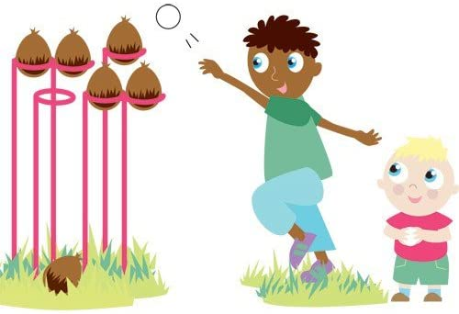

Activity 2 - Rock, Paper, Scissors – Workout!
Time to get hot and out of breath!
The first game is really simple but really fun (I hope). You will need at least one person to play against.
First you will have to play Rock, Paper, Scissors against your opponent.
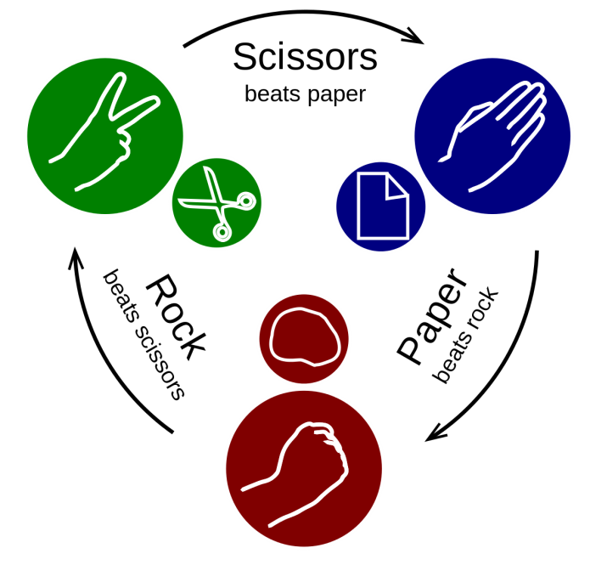
Whoever wins gets to pick a physical forfeit for the loser!
So if you can manage to win your game you can make the other play do any exercise you wish 10 times (10 Jumping Jacks, 10 Shoulder touch press ups, 10 Space Rockets etc)
If you manage to win 3 games in a row you double your opponents forfeit! So they’ll have to do 20!

Activity 3 – Sumo Tail Tag!

This game is one of my favourites. The first thing you will need is someone to play against (if everyone at home is busy, then just save the game for another point later today).

Mark out a circle pitch in your playing area.
Each player must tuck a bib/t-shirt/tea towel to make a tail. The tail needs to be tucked into the side of your shorts/trousers.
Without leaving the circle, one player has to attempt to pull out their opponents bib to win! (You will be attempting to do this to each other at the same time)
You are not allowed to touch your opponent – you can only touch their ‘tail’.

To add some extra spice to the game you could play ‘best of 3’. The loser has to do a physical forfeit that the winner chooses!

Enjoy!

