Upper Key Stage 2

Physical Education Lessons at home

UKS2 Lesson 1
‘The Science Experiment’
For lesson 1 you have to complete a series of challenges and we would like you to pay attention to how your body changes. One easy way to do this is by checking your pulse (this is a measurement of how fast your heart is beating).
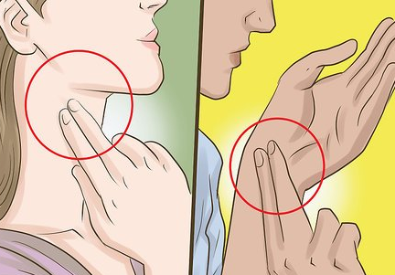
As you complete each challenge in our Science experiment write out your heart rate in the table below. Your heart rate is how many times you feel your heart beat in 60 seconds, so after completing the exercise find your pulse (see the picture) and count for 60 seconds!
The Science Experiment!
Challenge Number | The Challenge | Heart Rate (Count your pulse for 60 seconds)
1 | Lie completely still for 2 minutes
2 | Cross your arms and legs and sit for 1 minute
3 | Walk for 1 minute
4 | Jumping Jacks for 1 minute
5 | Jog on the spot for 1 minute
6 | Shoulder touch press ups for 1 minute
7 | Burpees for 1 minute!

You may have noticed that as the challenges get harder, your heart rate gets higher!
This is because your muscles use oxygen as fuel. So the harder you work the more oxygen you need, which means you breathe faster and your heart pumps the blood which carries the oxygen faster.
With that in mind – here is your next challenge. Complete this workout and every 3 minutes pause the video and find your pulse and count your heart rate.
Click the link and get ready!
https://www.youtube.com/watch?v=4dPXtS1aUII

Well done everyone!

UKS2 Lesson 2
‘Types of Training’
In this lesson we are going to learn about different ways to train your body. For every type of training we would like you to think about 2 things. 1) How hard did you find it? 2) Did you find it fun?
For each activity can you give it a score out of 16 for how hard you found it. 16 means it is as hard as running a marathon, 1 means you found it as easy as lying down with your favourite book!
Training 1: The first type of training you will do is called ‘Continuous Training’. This means you do the same type as exercise for a period of time without stopping. For this training you to do both of these activities please.
Continuous Training 1 – 3 minutes of continuous jogging without stopping
Continuous Training 2 – 90 seconds of continuous Jumping Jacks
Positives | - You don’t need much equipment to do it  - It works! If you do continuous training for long enough you will get fitter!  - Some people enjoy the feeling of going for a long run, bike ride to relax
Negatives | - It isn’t very sociable (you would normally do this type of exercise alone)  - Some people can find doing the same thing for a long time boring

Training 2:
Interval Training – The word interval means break. So for interval training you do exercise then you get a small chance to get your breath back before you start again. It means you can work a bit harder when it is your time to exercise again.
*Try and get someone else to join in with you*
Follow the link below and don’t forget to give the activity a score out of 16. Enjoy!
https://www.youtube.com/watch?v=591Stmzm9EA
Positives | - You get frequent rests, which means you can work harder!  - You can change how long you rest for – the fitter you get, the harder it gets!  - It works! You will get fitter!
Negatives | - It takes a bit of planning if you wanted to do it alone  - Or you’ll need to get some equipment if you want copy from a video (tablet, laptop etc)

Training 3:
Fartlek Training – Don’t panic, it’s Swedish. In Swedish Fartlek means ‘speed play’. For this type of exercise we’d like you to get used to changing speeds whilst you are running. You might need a bit of extra space for this one – maybe the garden or a park if you have someone to go with?
This is what we want you to try.
Imagine you’re a car with 3 gears (make the engine noise if it helps).
Gear 1 = Walking, Gear 2 = Jogging, Gear 3 = Sprinting
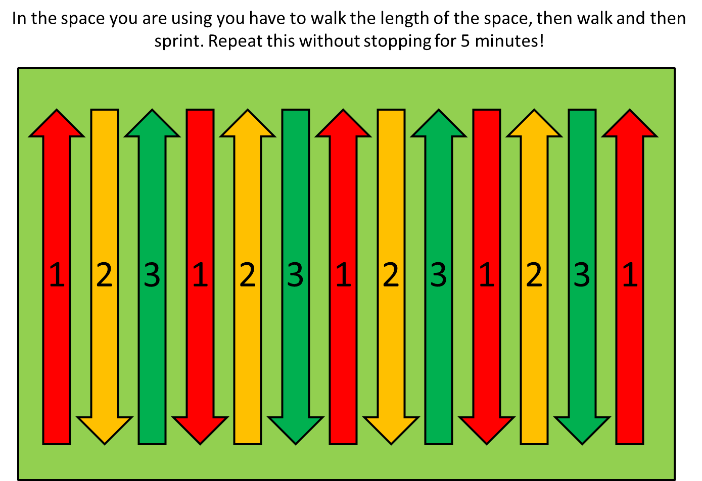
Positives | - It works! You will get fitter  - It is very useful for people who play team games (Hockey, Football, Rugby, Netball etc). The change of speed is the same as how you move when you play these games
Negatives | - Not much fun if you don’t like running!

UKS2 Lesson 3
‘Different types of fitness’
*Warm-up question* – Ask all of the people at home you’re with who they think is the fittest person in the world. Make sure you ask people why too!

